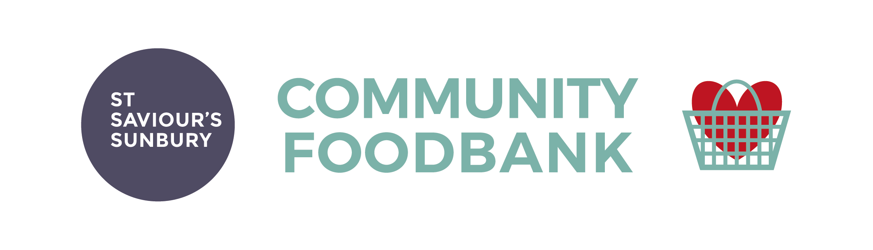
REFERRAL FORM
Referral Date: | Client’s name:
Client’s contact number: | Client’s address:
Client’s date of birth: | Has this client been referred to us before?
Referrer: | Referral agency:
Contact details (phone and email): | Position held:

 | Main Client | Person 2 | Person 3 | Person 4 | Person 5 | Person 6
Age

Gender: M/F

Dietary Needs/Allergies

Nappy size

Baby food: Y/N

Available cooking facilities (please tick) | Oven | Hob | Microwave | Kettle | None

Reason Client requires assistance:

Any other information (eg mobility/health issues)

Would the client benefit from joining one of our courses? (community recovery programme and/or community life skills course) | Community Recovery Community Life Skills/Money
Would this client benefit from a £50 fuel ‘top up’ payment? | Yes  No
Has the client used or been made aware of the Government’s ‘Warm Home payment scheme? | https://www.gov.uk/the-warm-home-discount-scheme  Yes No
Does the client have arrears on their fuel accounts? | Yes No  If yes, St Saviour’s will send you an application form for our Fuel Arrears Payment Scheme.

The Community Foodbank at St Saviour’s Sunbury is a charity run under the auspices of the Parish of Sunbury-on-Thames. It targets families and individuals who other agencies (both statutory and voluntary) perceive as being in emergency need of food and household essentials.
The Community Foodbank at St Saviour’s Sunbury is committed to the principle of equal opportunities for all of its clients and volunteers regardless of race, gender, marital status, sexual preference, ethnic origin, religious beliefs, or disability.
In order to comply with data protection legislation please tick here to confirm that your client consents to receiving a food parcel, and also to their personal details being stored by the Community Foodbank at St Saviour’s Sunbury and shared with the trustees of the Fuel Payment Scheme. These details will only be held on our database and will be used for statistical purposes only. Any details stored will not be shared with any third party.

St Saviours Church Office, Vicarage Road, Sunbury-on-Thames, Middlesex, TW16 7TP
E-Mail: community@stsaviourssunbury.org.uk
Tel: 07496 524693

